Yelena Muradyan
September 19, 2024

Executive Summary
The "Library" feature centralizes all user-collected sources (links only) across projects, offering easy access and search capabilities via keywords and tags. It enhances efficiency by allowing users to organize, duplicate, and manage links. Positioned in the Unassigned section, this centralized database simplifies resource management, improving overall workflow and productivity.
Feature Name | Library
Product Area | Unassigned sources/ App
User Persona/ Story | Recruiters
Description | Overview  The "Library" feature will serve as a centralized repository for all sources collected by the user on the platform, organized by projects. It will be positioned as the second toggle-tab in the "Unassigned" section of the platform, allowing users to view and search for any link or source using keywords from titles or assigned tags. On a source card alongside all requisites, each source card will also display the project name it is associated with.  Key Features  - List of all links available in the workspace  - Search  - Friction-free duplication of a source to to any project  - Duplicated source’s attributes management modal
User Problem | Users often struggle to locate specific sources they have already collected across various projects, wasting time switching between projects. Additionally, users lack an intuitive, centralized space to organize, duplicate or retrieve the links they've in their database, leading to frustration and inefficiency in managing research or knowledge resources.
Value Proposition | The Library feature solves this problem by giving users a comprehensive, searchable, and organized repository of their sources. It consolidates resources from different projects in one place, allowing for easy retrieval, enhanced overall database visibility, and more efficient workflow management.
Objectives | - Centralized database of all sources collected within a particular workspace  - Improve user experience by providing a centralized space for managing and accessing all links.  - Reduce the time to find a particular source by offering a robust search feature.
Assumptions | - Users will benefit from having a centralized source management system instead of relying solely on project-specific collections.  - Search functionality using keywords from titles or tags will be sufficient for users to locate their links.  - Project names on the source cards will help users identify and differentiate sources quickly.  - Some duplicating sources might already be in the project. Consider handling this edge case.
MVP | - A toggle-tab in the Unassigned section called "Library."  - All links aggregated from different projects in one centralized view.  - Search functionality for links using keywords from the title or assigned tags.  - Duplicate source to any project by drag & drop  - Source attributes editing modal
Out of Scope | - Advanced sorting options (e.g., by date added, frequency of use).  - Automated categorization or tagging of links.
KPIs | - Growth in feature adoption rate (percentage of users who actively use the Library tab).  - Increase in total sources managed through the platform.
Requirements | - Centralized access to Library where users should be able to view all their collected links across various projects from the Library tab, which is accessible as a”toggle” :D in the Unassigned navigation bar.  - Search functionality with keywords and tags should allow users to search for any link within the Library using keywords from the source title or tags.  - Source card should display the project name for easier identification and differentiation.  - Users should be able to easily duplicate any source to another project using drag-and-drop functionality. After duplication, a modal for managing attributes (e.g., title, tags, notes) should appear for quick edits/add ons.  - When duplicating a source, users should have the option to edit the source's title,add new notes, or tags in a pop-up modal.  - Users should be able to allow transfer of existing attributes of the source to be inherited by ticking a checkbox. 9see below for inspo)  - If a link already exists in a project, any new duplicates from the Library should be treated as annotations or additions to the existing source, instead of creating a new entry.
High Lvl Mocks | 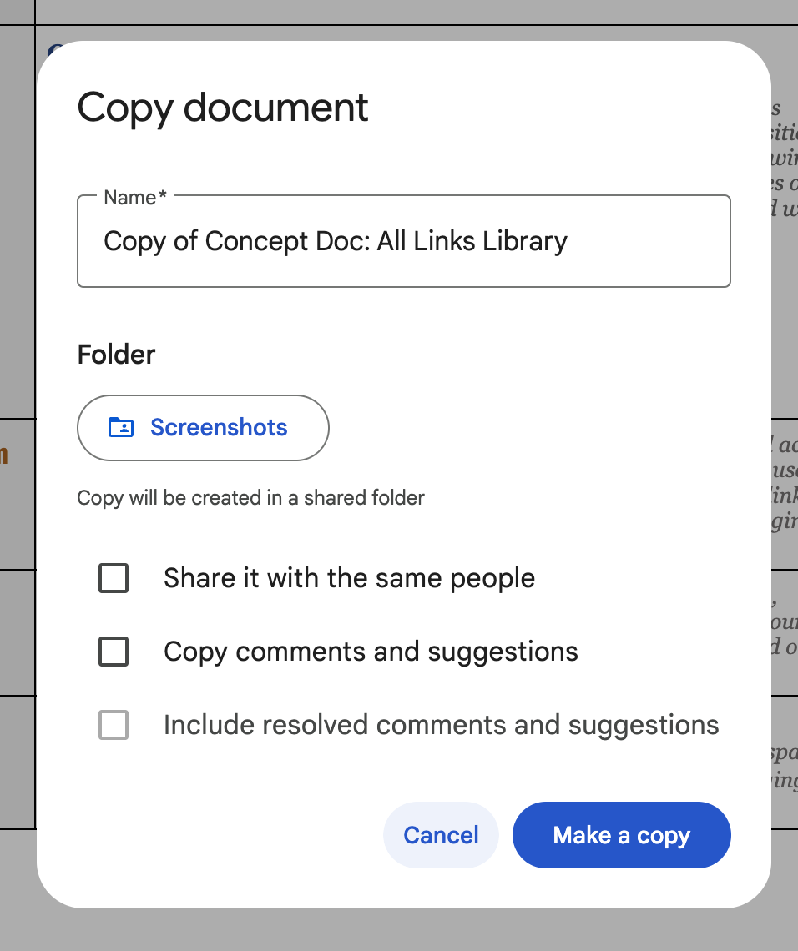  Duplication Modal Inspo from Google Docs

